MASSMINE FOR THE MASSES

A Project

Presented to the

Faculty of

University of North Carolina,

Greensboro

In Partial Fulfillment

of the Requirements for the Degree

Master of Science

in

Computer Science

by

(Anusha Vanama)

(May 8, 2020)

© (2020 and Anusha Vanama)

ABSTRACT

Massmine is a command line tool designed for researchers to simplify the collection and use of data from online sources like Twitter. It can pull massive amounts of data and give them to the user for further analysis. Massmine allows users to see data being collected and view it in real-time, from multiple social media platforms, and provide some form of user collaboration. Massmine is designed to run on Linux and Mac OSX. However, it is not easy for all users to work with it as it is a command line tool in the Linux operating system. The data is produced in such a way that it is difficult to parse for the non-technically oriented.

Currently, there is a web application that allows a user to create queries for Twitter data in a user interface which is simple and easily understandable. The web application can be easily operated by all Massmine users who are not familiar with a terminal interface and it is approachable for everyone. The user can also perform basic analysis on data in a simple graphical user interface without interacting directly with data.

The user can login into the web application using his credentials. The user needs to enter the search terms and number of tweets and submit the query. Once the user submits the query, then this information is sent to a Massmine instance running on the host server. The data will be parsed and stored in a database once it is retrieved from this Massmine instance. The user can view and access the retrieved data through this web application.

The main goal of this project is to redesign all the pages in the existing web application to enhance the user experience and offer smooth navigation throughout its design. The side navigation bar will give a seamless flow throughout the tool.

ACKNOWLEDGEMENTS

I would like to express my special thanks of gratitude to my professor Dr. Somya Mohanty for providing his invaluable guidance, encouragement, insightful comments and suggestions throughout the course of the project. His guidance helped me in all the time of project.

I would also like to extend my gratitude to the professor Dr. Aaron Beveridge for his assistance during the period of my project work.

TABLE OF CONTENTS

ABSTRACT 3

ACKNOWLEDGEMENTS 4

INTRODUCTION 6

REQUIREMENT SPECIFICATION 7

SYSTEM DESIGN 9

SYSTEM OPERATION/11EVALUATION 11

CONCLUSION 27

CHAPTER ONE  
introduction

Massmine-for-the-Masses is an open source, proof of concept tool. It extends the functionality of the big data gathering tool Massmine which is a command line interface. Massmine-for-the-Masses has a graphical user interface which allows users to see data being collected and view it in real time, from social media platforms. It may be installed as a Docker image in a Docker container, or installed manually onto a compatible Linux machine. It is a web application built with the Django framework, using Django’s default test server and SQLite database.

The user can register into the application using his private Twitter Developer keys. The user can submit a query by providing the query information like the search term and number of tweets. Once the user submits a query, the information is sent to the Massmine tool for further processing. The twitter data is retrieved back from the tool which is parsed and stored into a local database. The user can further view and perform analyses on the tweets corresponding to the provided search term in the web application.

The user can perform four types of Analysis. Analysis include sentiment analysis, sort by date and time, view the top five most associated words with the search term and view all tweets related to that search term.

CHAPTER TWO  
Requirement Specification

# Project Requirements

## Usability

Home page interface. Should allow the user to select one of the social media networks like Twitter, Instagram, Tumblr, YouTube, Facebook. After selecting one of the data sources, User should be navigated to the corresponding login page.

Twitter Login interface. Allow user to create the accounts using Sign Up link. It also allows user to Login using his credentials like Username and Password. It should also allow him to reset his password using Forgot Username/Password link.

Twitter Home page interface. Allow the user to select one of the options from side navigation bar. User should be able to navigate to the interfaces like Analysis, Query, Admin, Edit Profile, Change Password, Logout.

Query interface. Allow the user to create queries. User should be able to enter search term and number of tweets count before submitting a query. A new study should be created as soon as the query is submitted.

Analysis interface. Lists the studies that a user has access to and allows them to create analysis on those studies. All the studies should be displayed in a table. User should be able to view the details like Study Id, Number of tweets, Time Stamp, Username and create analysis button for each study. Allow the user to select one of the Studies and perform analysis by clicking the Create Analysis button corresponding to that study. After clicking on create analysis button, User should be able to navigate to a page where he can choose one of the four options like Sentiment Analysis, Frequently used words(Most associated words with that study), Sort by Date(Tweets over time for that study), View all tweets.

CHAPTER Three  
System Design

**Entity Relationship Model of the System**

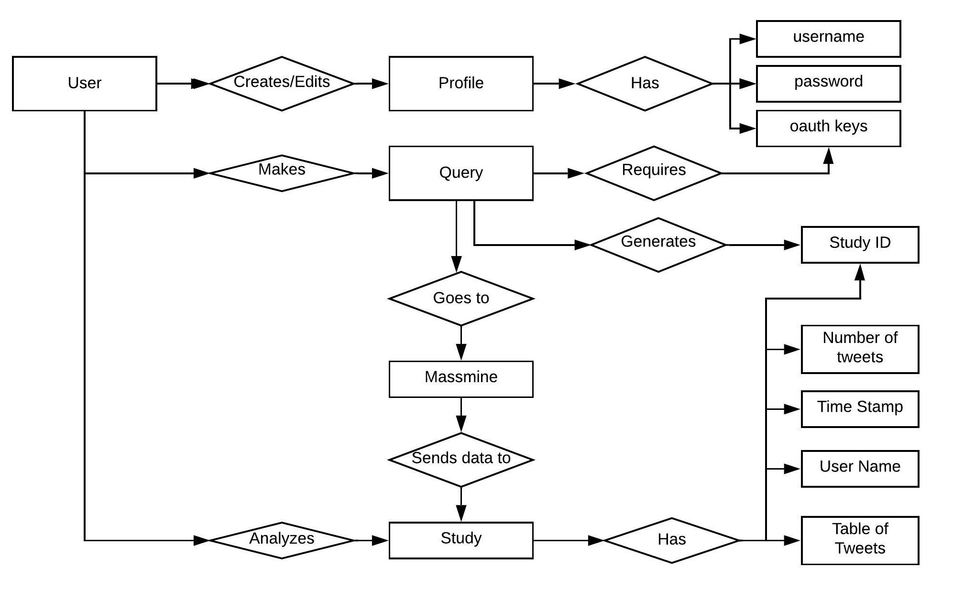

**Database Entity Relationship Model**

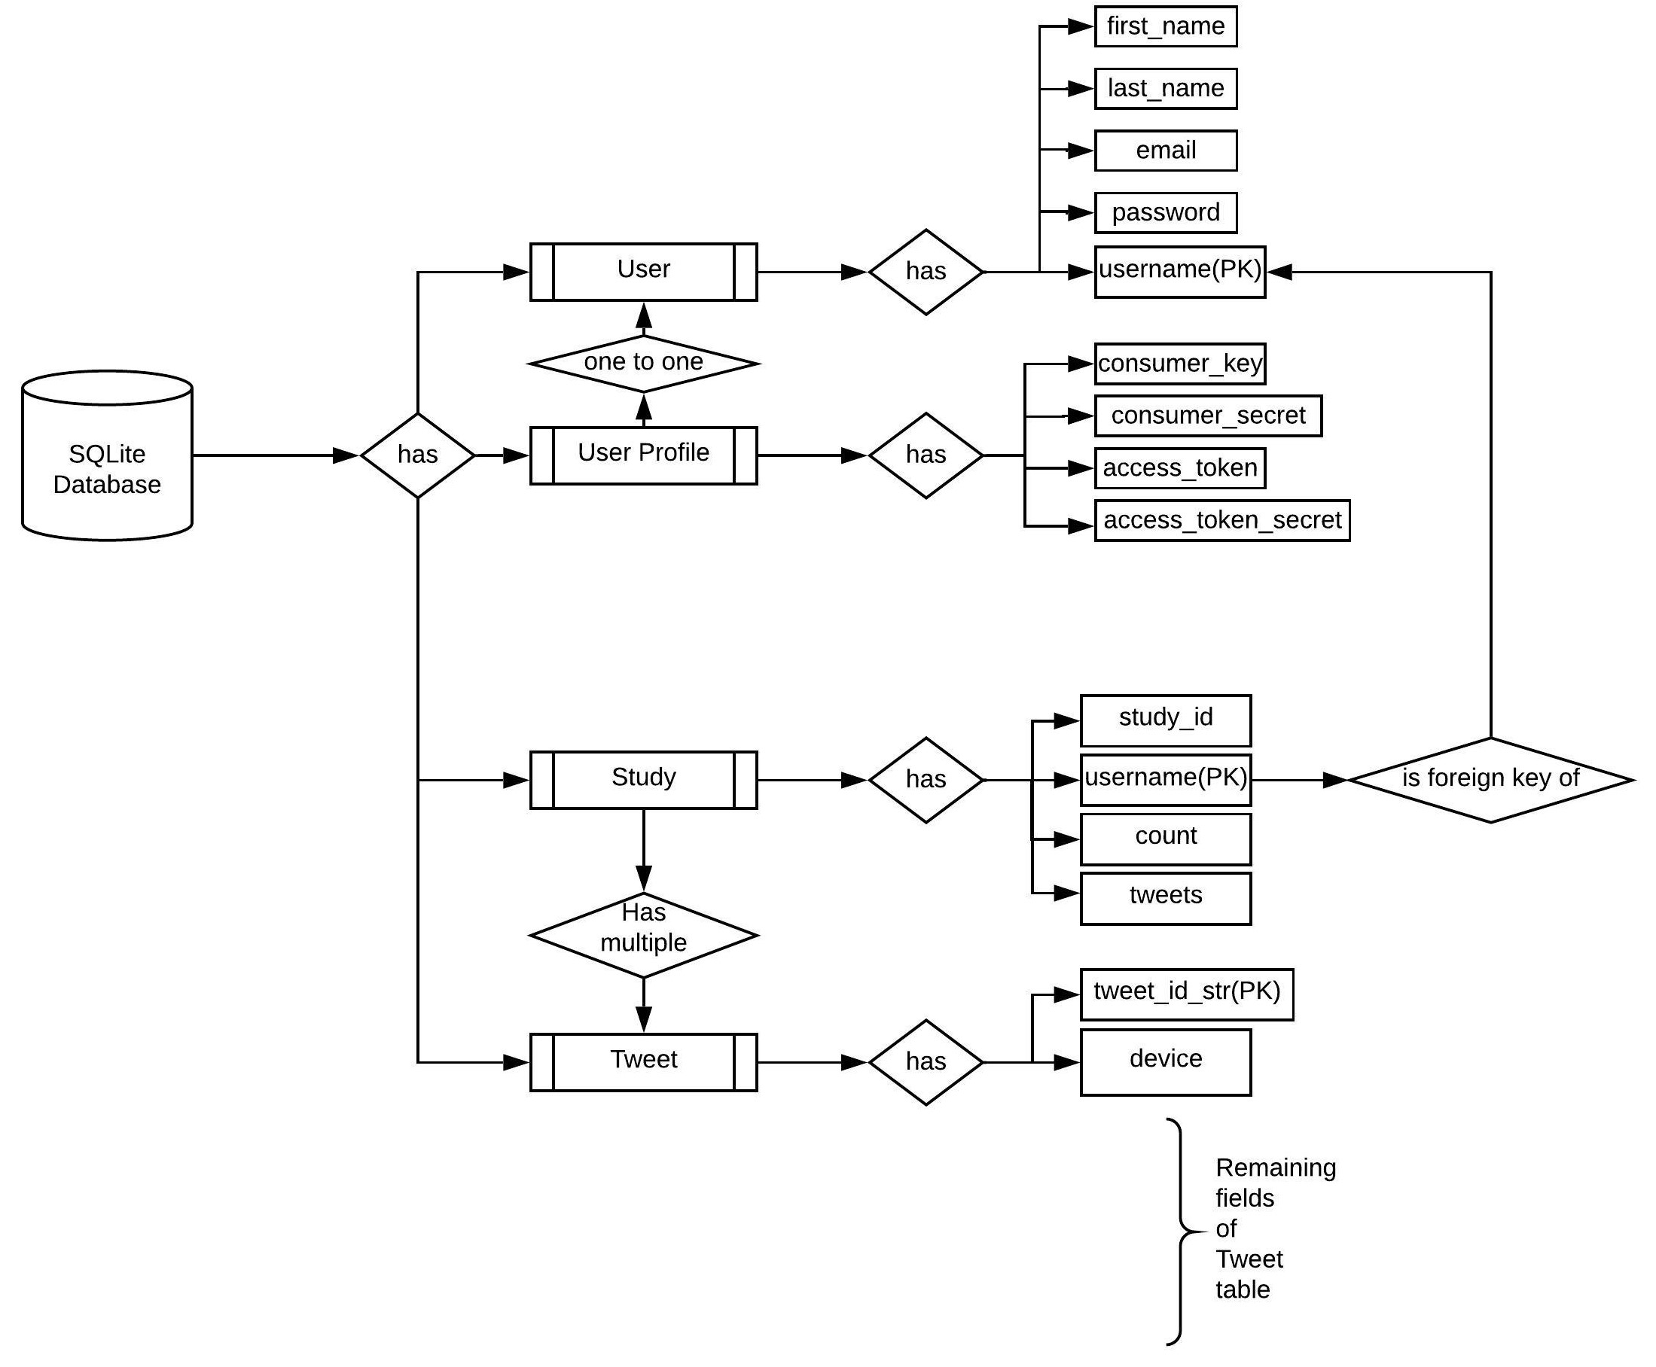

CHAPTER Four  
System Operation/EvaluatioN

**Selection of a Data Source Scenario:**

Case: Selecting a data source

Actor: User named AnuVanama, not logged in or created

Scenario: AnuVanama would like to view tweets related to Super Bowl game. She goes to the desktop where Massmine-for-the-Masses application is running and selects Twitter as the data source.

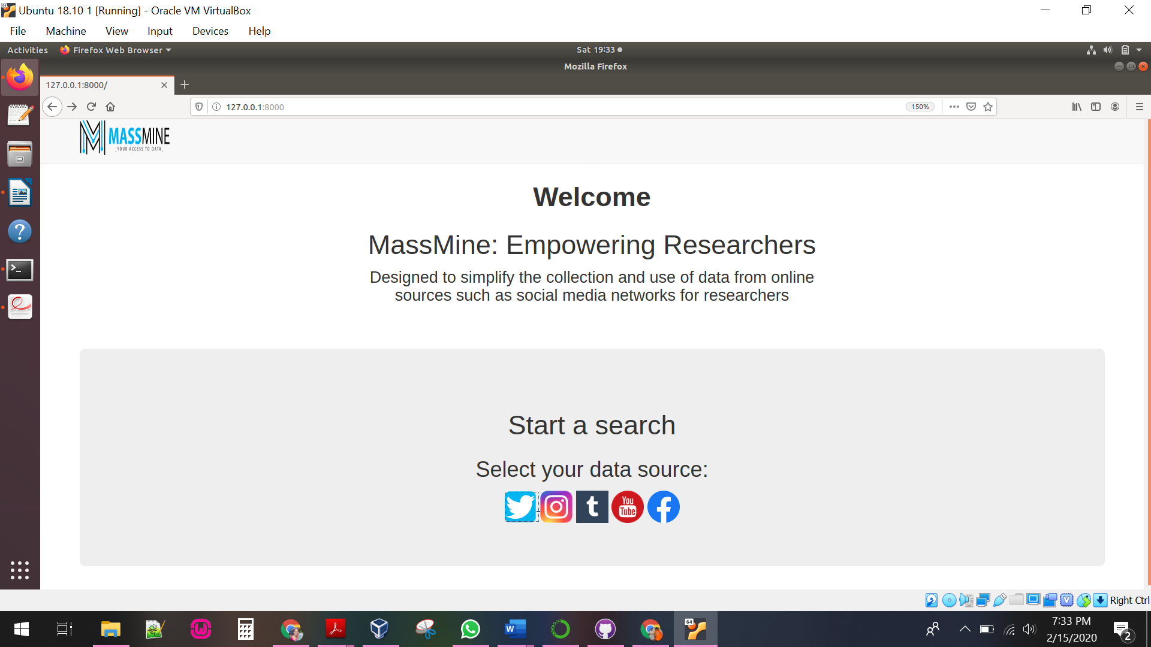

**Registration and Login Scenario:**

Case: Creating a new user

Actor: User named AnuVanama, not logged in or created

Scenario: AnuVanama would like to create an account on the Massmine-for-the-Masses website. She selects data source as Twitter in the Massmine home page and clicks on Sign Up link at the bottom of the twitter home page. She enters all the required details and clicks ‘Submit’ at the bottom of the page and is

returned to the twitter home page. She enters her username and password on the login screen and clicks on Login button. After clicking on Login button, she is navigated to the Main Dashboard and the message ‘Hello AnuVanama’ appears on the screen. She can see a side navigation bar which contains options such as Analysis, Query, Admin, Edit Profile, Change Password and Logout.

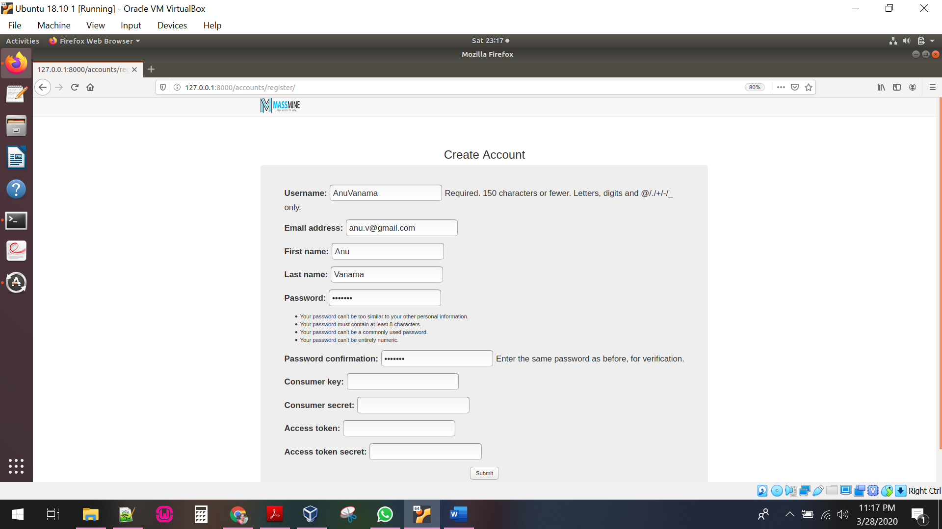

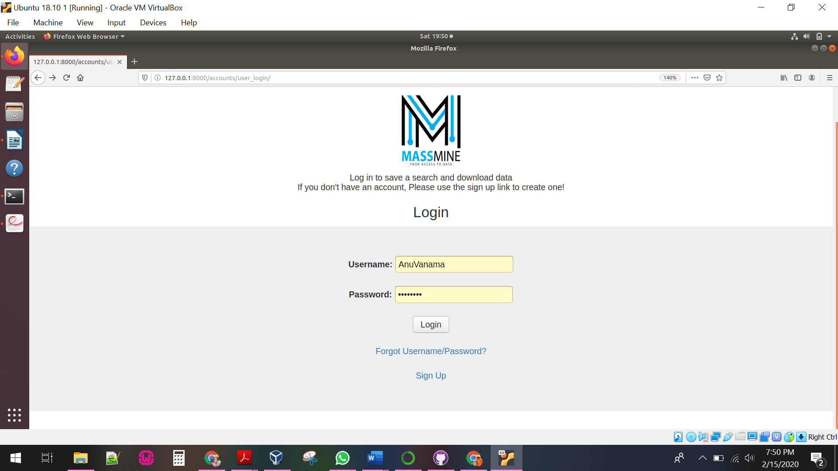

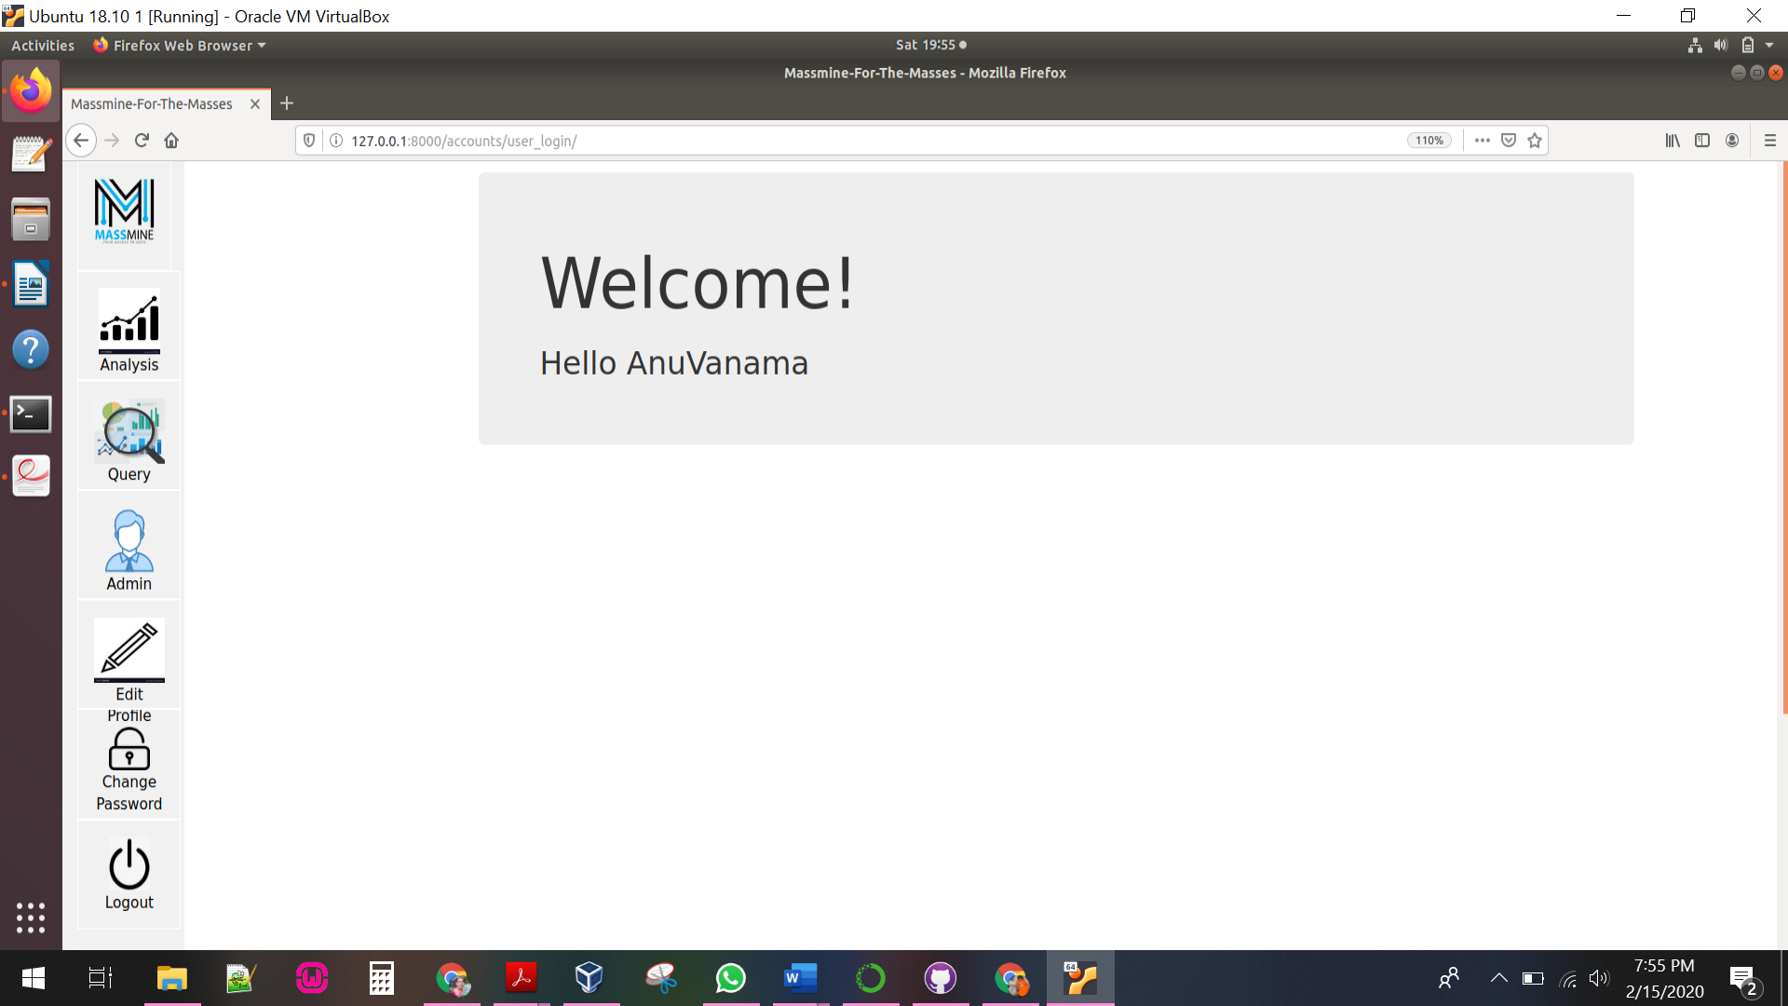

**Creating a query Scenario:**

Case: Creating a new query

Actor: User named AnuVanama, currently logged in

Scenario: AnuVanama (after logging in) would like to view tweets related to Super Bowl game. She clicks on query icon located in the side navigation bar. Query page allows her to enter a keyword or phrase of her choice, and the number of most recent tweets containing that keyword or phrase together. This page validates her Twitter authorization keys and informs her if the keys are invalid. Query details are sent to Massmine to begin the query process if her keys are valid. Once the query is completed successfully, A new study is created which can viewed further in Analysis tab.

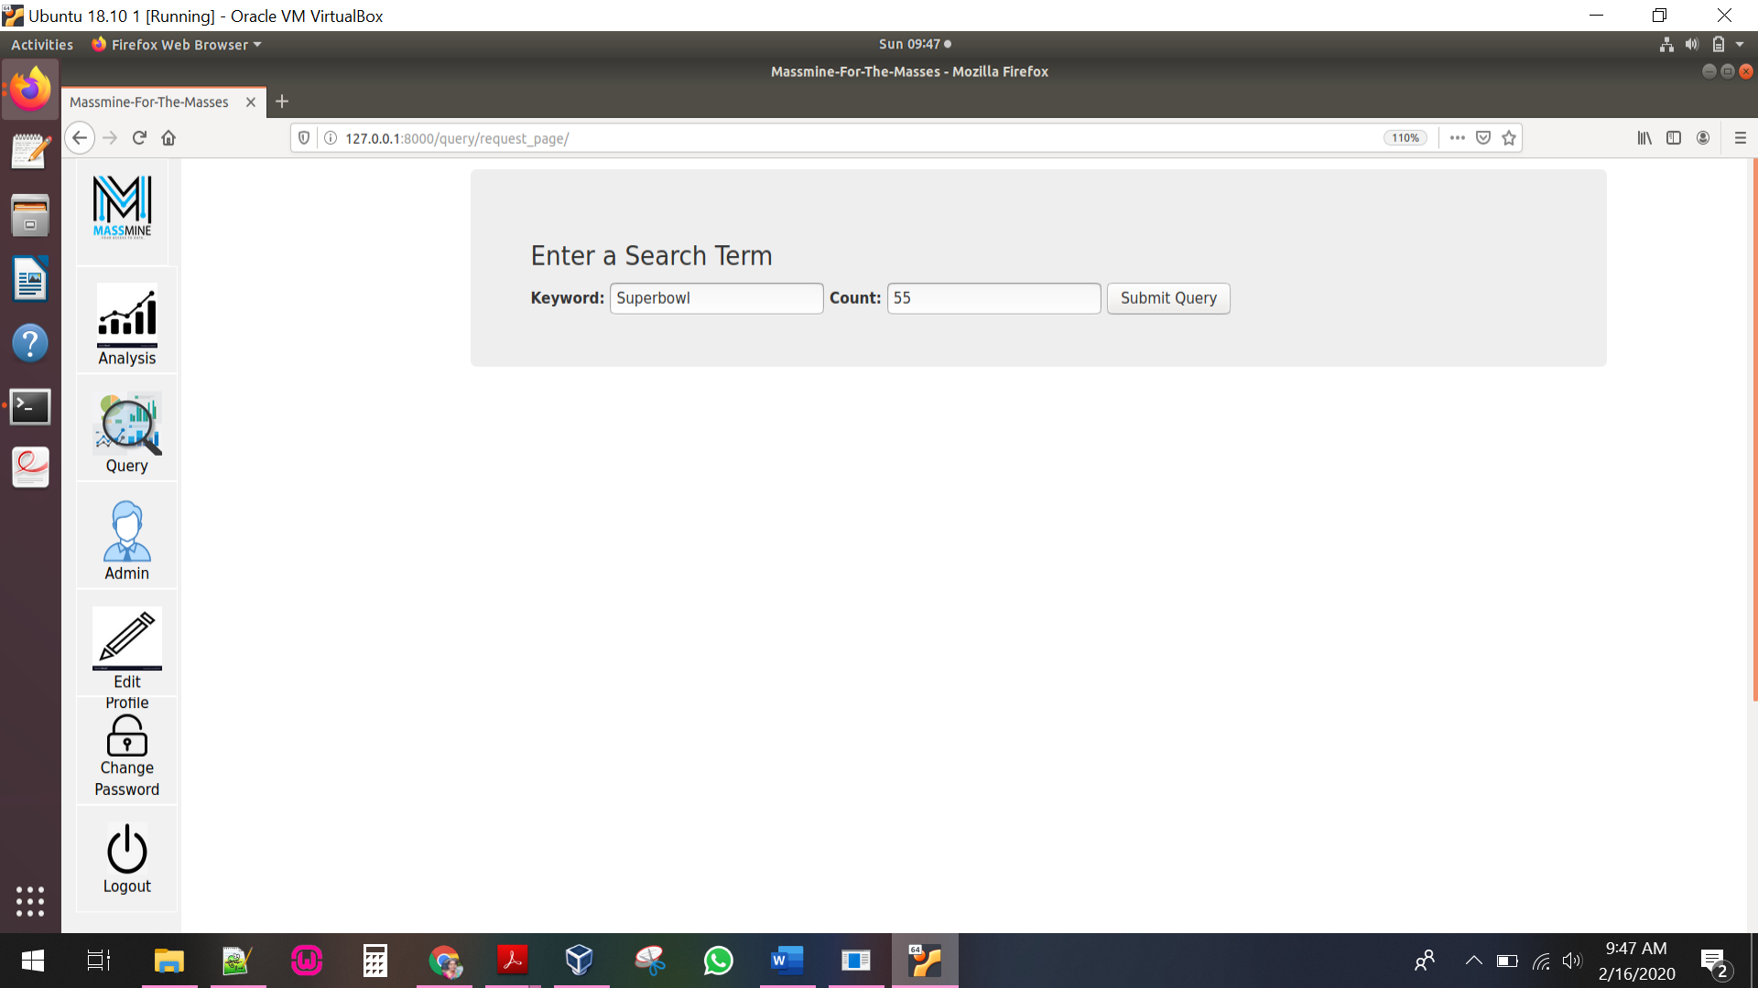

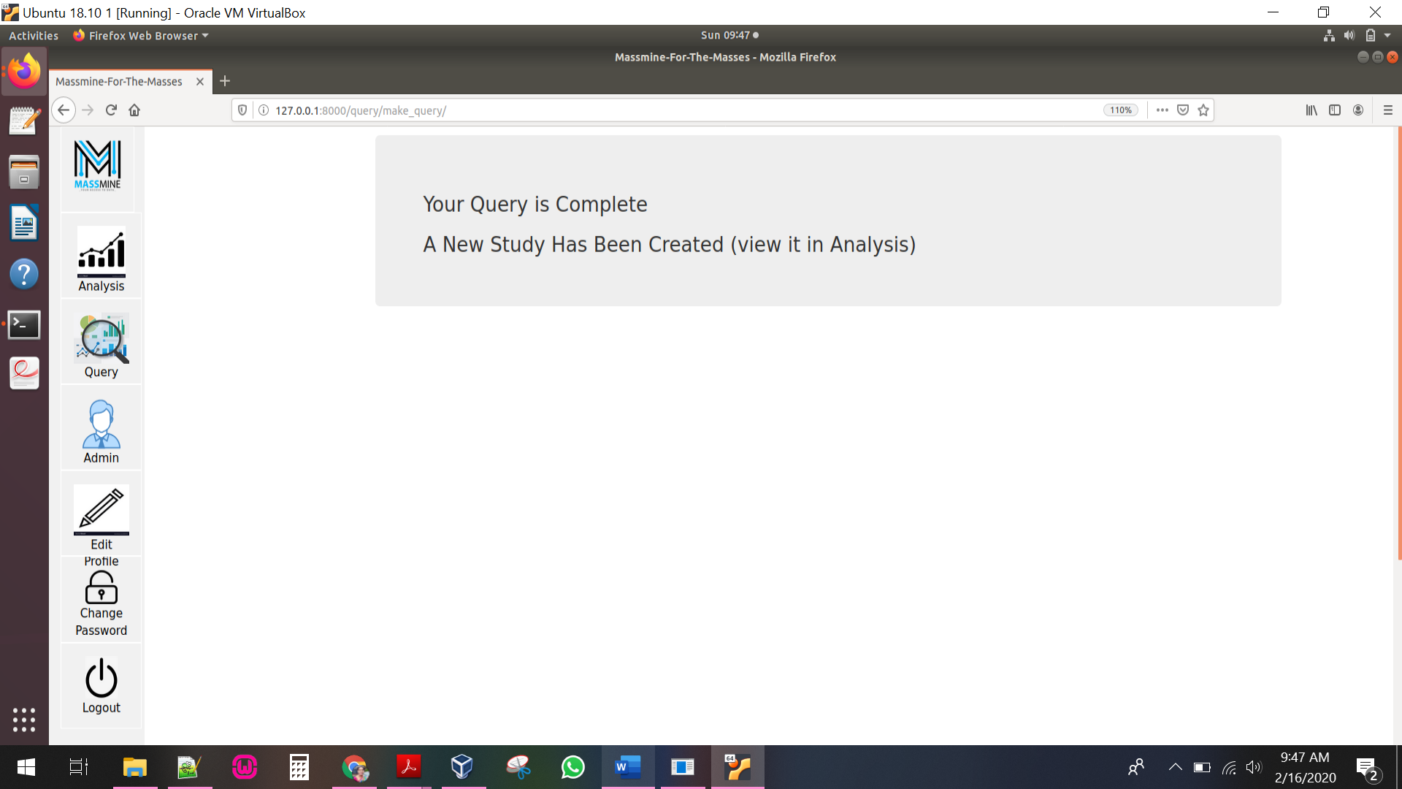

**View Studies Scenario:**

Case: View all studies queried by the user

Actor: User named AnuVanama, currently logged in

Scenario: AnuVanama (after logging in) would like to view all the studies queried by her. She clicks on Analysis icon located in the side navigation bar. Analysis page allows her to view all the studies in a table.

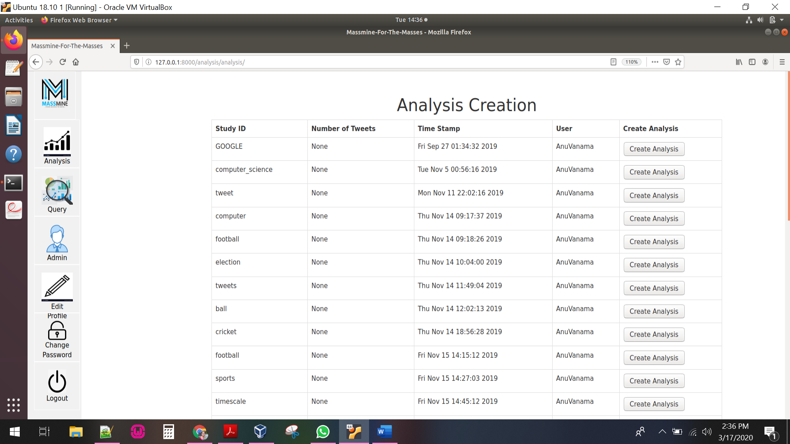

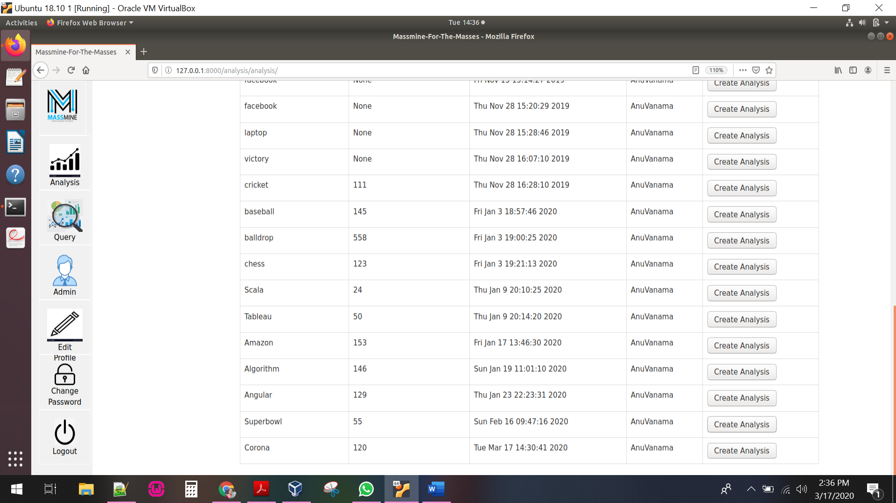

**Analysis Creation Scenario:**

Case: Create analysis on studies queried by the user

Actor: User named AnuVanama, currently logged in

Scenario: AnuVanama (after logging in) would like to create analysis on one of the studies queried by her. She clicks on create analysis button located in the table corresponding to each of the study. It allows her to navigate to a page where she can select one of the analysis options like Sentiment Analysis, Frequently Associated words, Sort by Date and View Tweets related to that study.

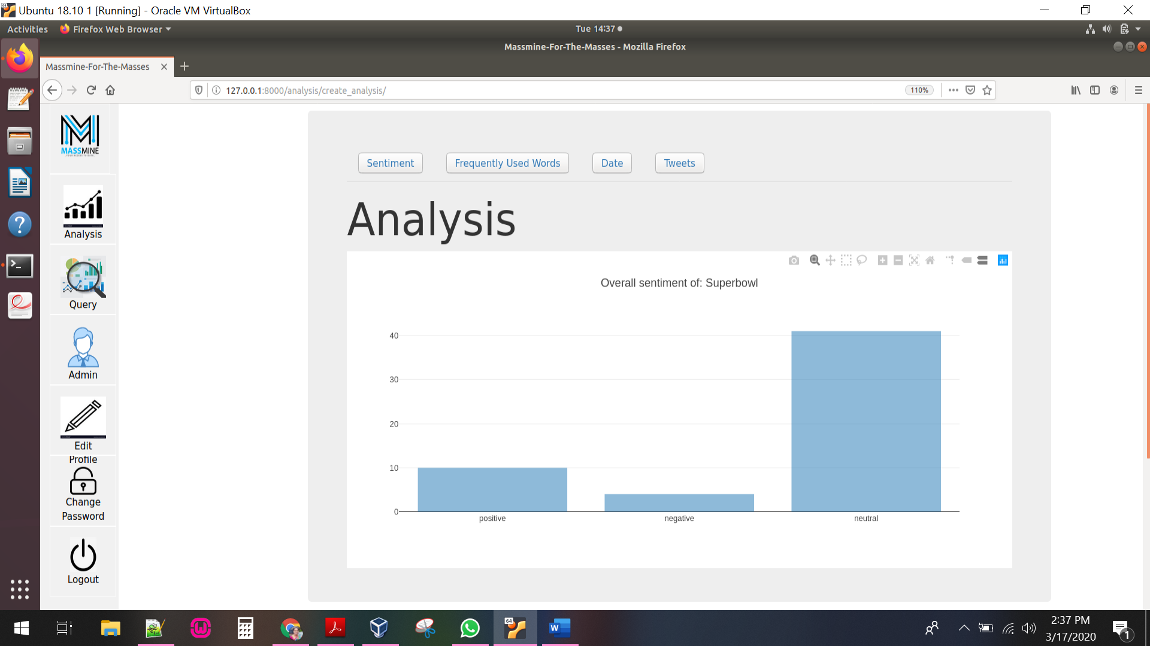

**View Sentiment Analysis Scenario:**

Case: View the overall sentiment of a study

Actor: User named AnuVanama, currently logged in

Scenario: AnuVanama (after logging in and creating a study) navigates to the analysis page. She first selects a study she queried for from the table in the Analysis page. She then clicks on Create Analysis button corresponding to that study. She is navigated to a new page which displays the options for different types of Analysis. She then selects the Sentiment tab and then she is navigated to a page which displays the overall sentiment (how many tweets are positive, negative, or neutral) based on the original keyword queried for. She hovers her mouse over one of the bars in the graph to see how many tweets were labeled as ‘neutral’.

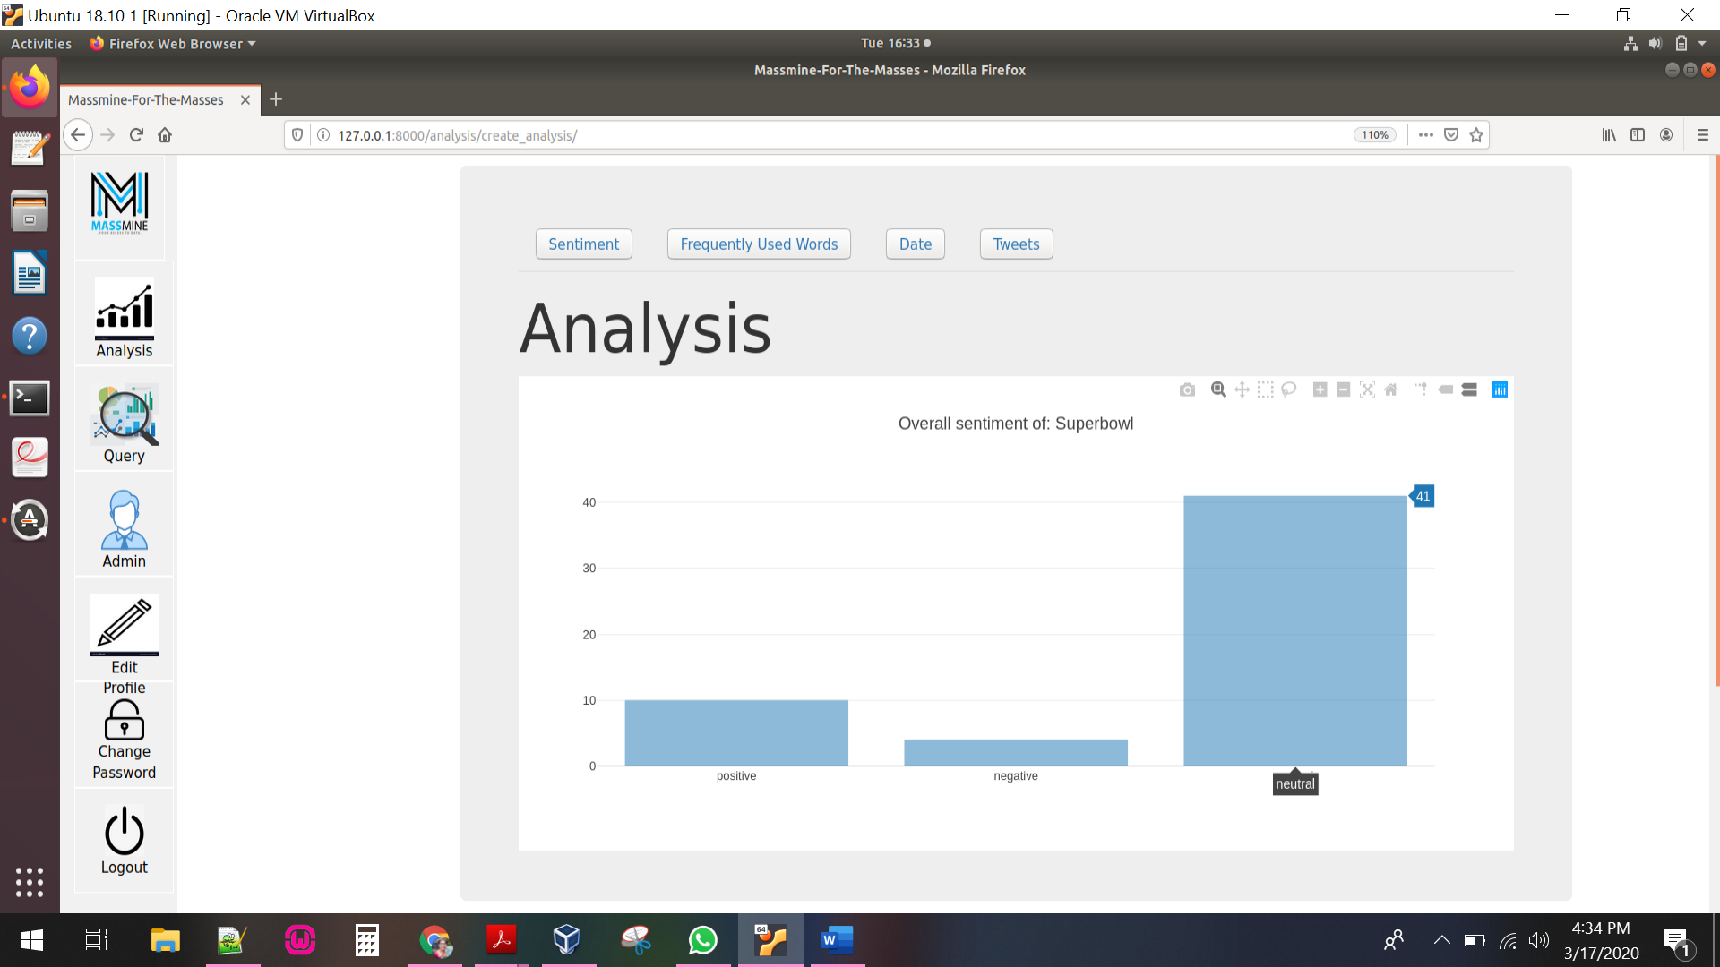

**View Frequent Words Scenario:**

Case: View the top five most frequently used words in a study

Actor: User named AnuVanama, currently logged in

Scenario: AnuVanama (after logging in and creating a study) navigates to the analysis page. She first selects a study she queried for from the table in the Analysis page. She then clicks on Create Analysis button corresponding to that study. She is navigated to a new page which displays the options for different types of Analysis. She then selects the Frequently Used Words tab and then she is navigated to a page which displays the top five most frequently used words based on the original keyword queried for. She hovers her mouse over one of the bars in the graph to see how many tweets were labeled as ‘comment’ along with Superbowl. She zooms into the map to see it in more detail. She also right-clicks and saves the graph as an image so she can review it later.

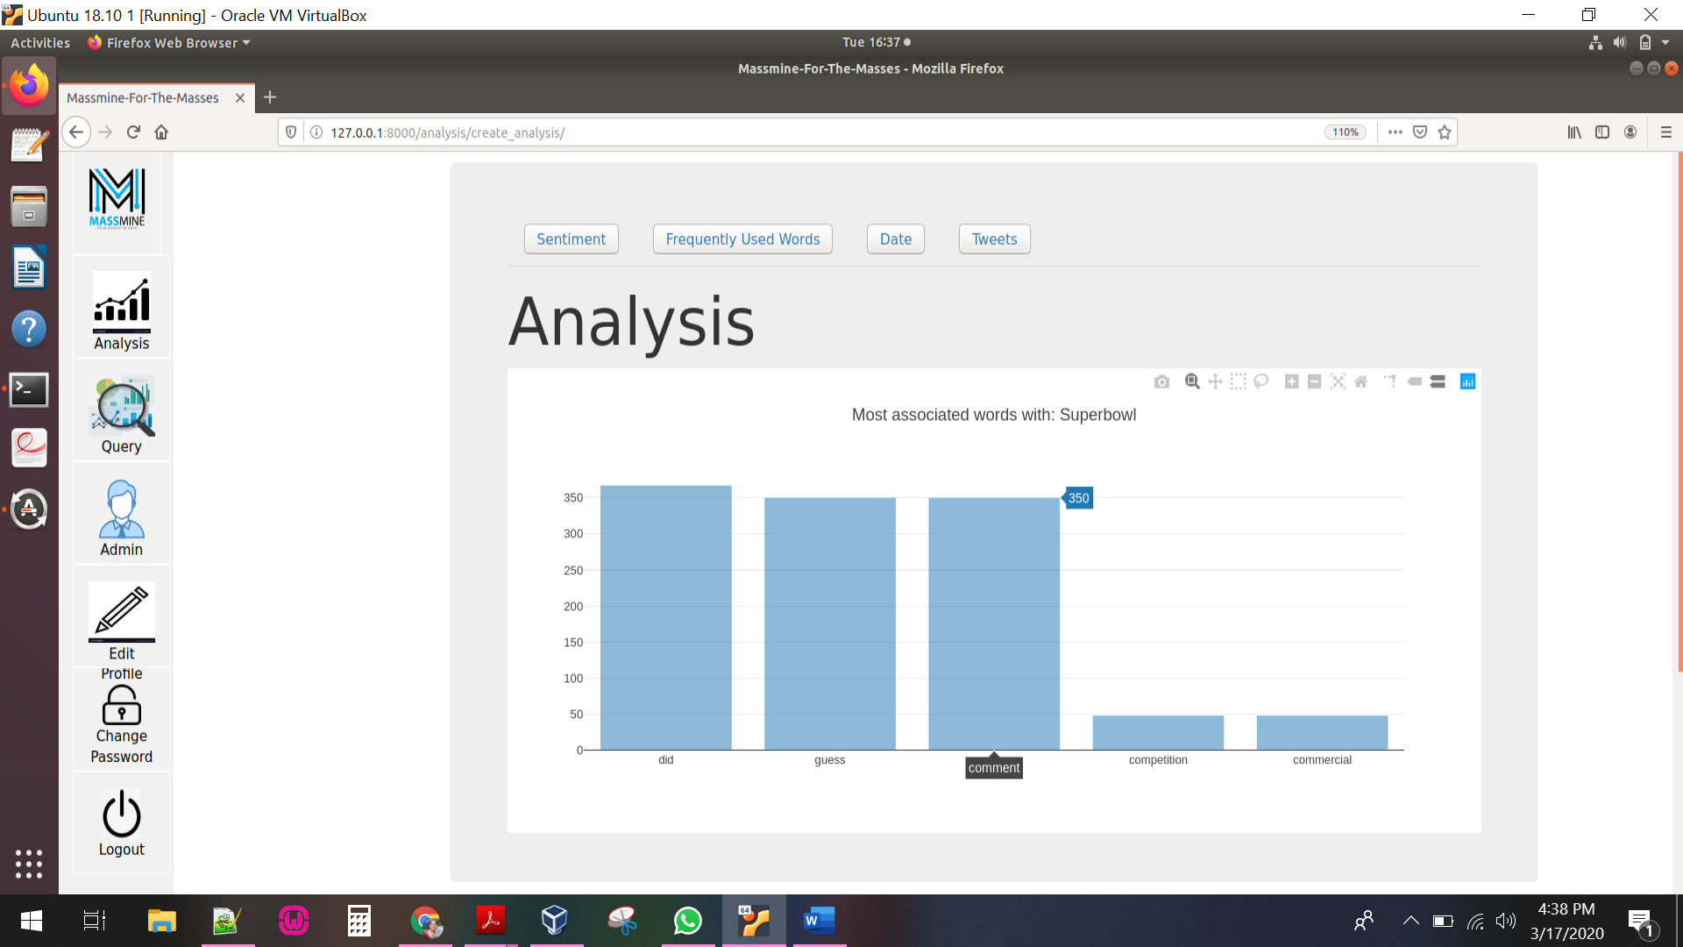

**Sort by Date Scenario:**

Case: View the activity of a study

Actor: User named AnuVanama, currently logged in

Scenario: AnuVanama (after logging in and creating a study) navigates to the analysis page. She first selects a study she queried for from the table in the Analysis page. She then clicks on Create Analysis button corresponding to that study. She is navigated to a new page which displays the options for different types of Analysis. She then selects the Date tab and then she is navigated to a page which displays the timeline of the tweets being posted based on the original keyword queried for. She hovers her mouse over one of the nodes to see how many tweets were posted at this particular date and time. She clicks and drags the graph right and left to see the timeline.

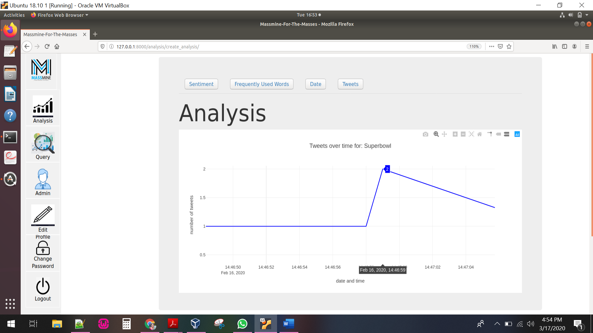

**View Tweets Scenario:**

Case: View Tweets of a study

Actor: User named AnuVanama, currently logged in

Scenario: AnuVanama (after logging in and creating a study) navigates to the analysis page. She first selects a study she queried for from the table in the Analysis page. She then clicks on Create Analysis button corresponding to that study. She is navigated to a new page which displays the options for different types of Analysis. She then selects the Tweets tab and then she is navigated to a page which displays all the tweets associated with that study.

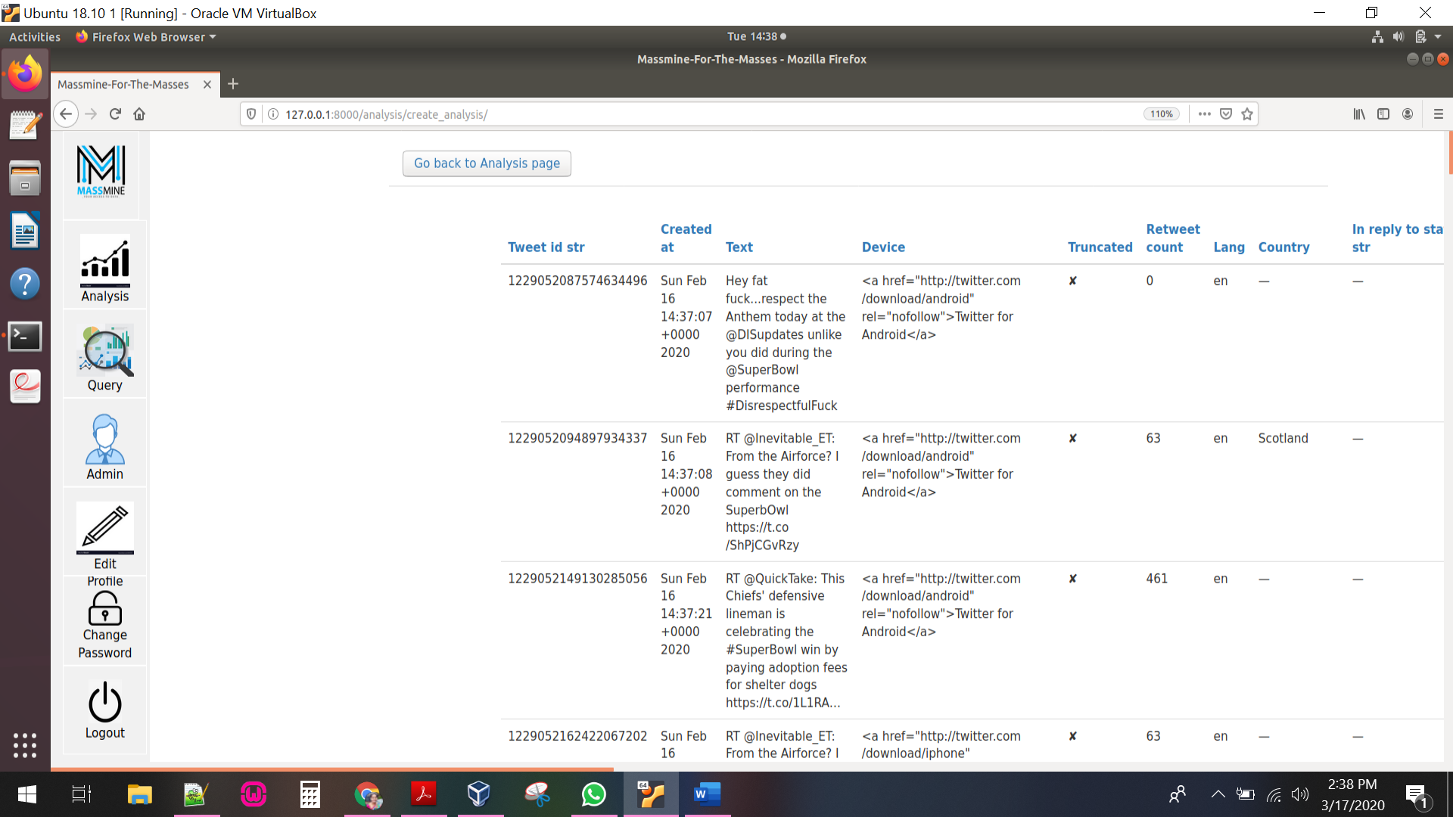

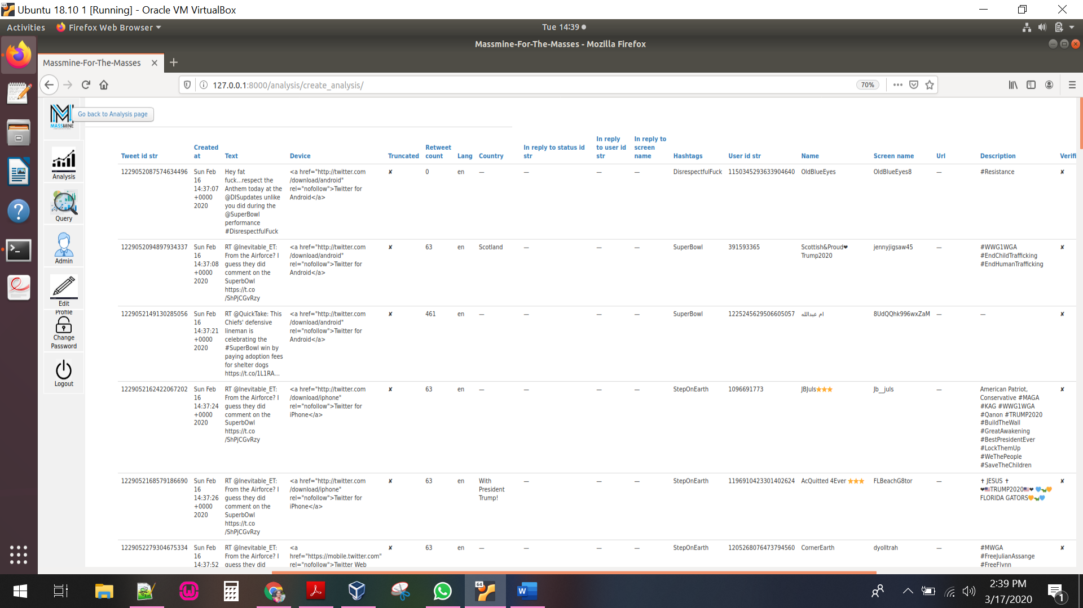

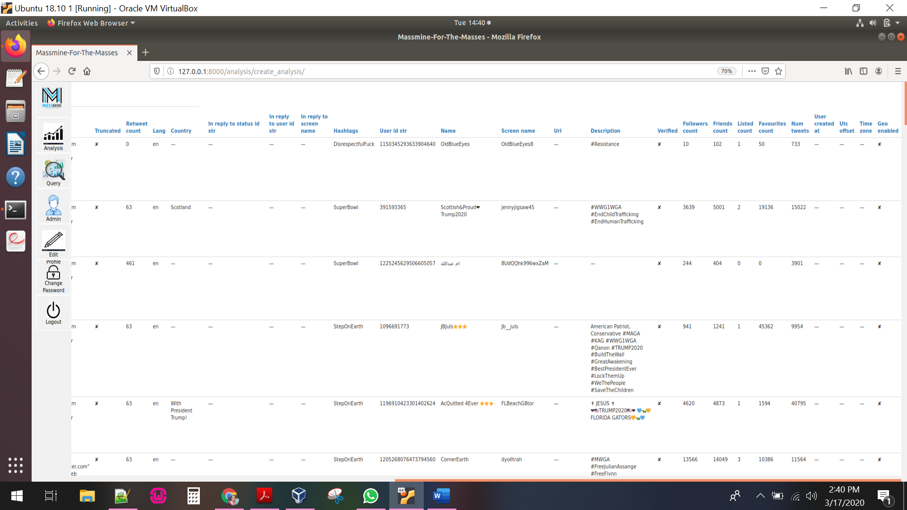

**Edit Profile Scenario:**

Case: Editing a user’s profile

Actor: User named AnuVanama, currently logged in

Scenario: AnuVanama realizes that she entered the wrong details in for her

Twitter Access token. She clicks ‘Edit Profile’ on the side navigation bar. She is navigated to a page which displays her details like email address, first name, last name, and all four Twitter authorization keys. She clicks on the Access token text

field, and edits the field to enter the correct information. Then she clicks ‘Submit’ at the bottom of the page. She is navigated to home page after clicking on submit button.

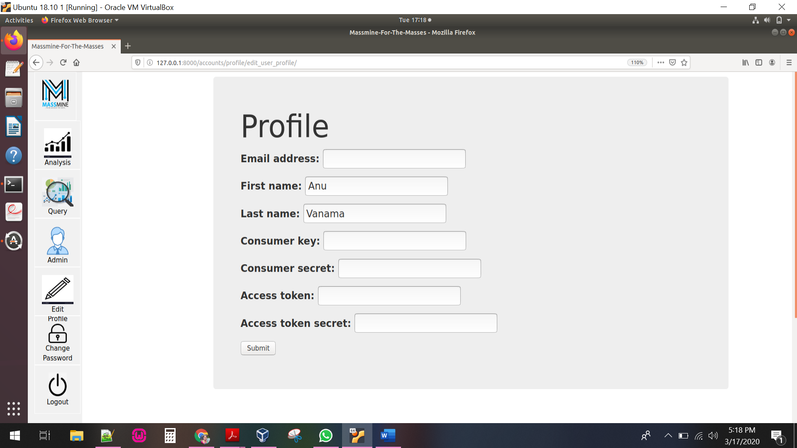

**Change Password Scenario:**

Case: Editing a user’s password

Actor: User named AnuVanama, currently logged in

Scenario: AnuVanama realizes that her password is insecure and wants to

update it. She clicks on Change Password icon located in the side navigation bar.

She is navigated to a screen which allows her to enter her old password, a new password, and a confirmation of the new password. It also displays few instructions that her password can’t be too like her other personal information, her password must contain at least 8 characters, can’t be a commonly used password, and can’t be entirely numeric. AnuVanama enters her old password and updates another new password as the new password and confirmation. Now, an error is displayed informing that the new password does not meet the requirements.

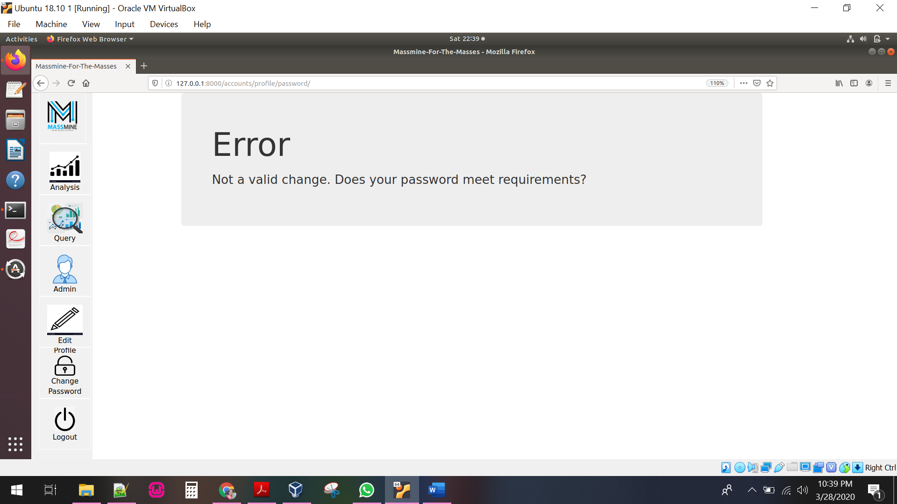

She then clicks on Change Password again, and this time enters her old password and updates her password which meets the above criteria as the new password and password confirmation. Now, she is navigated successfully back to the home screen.

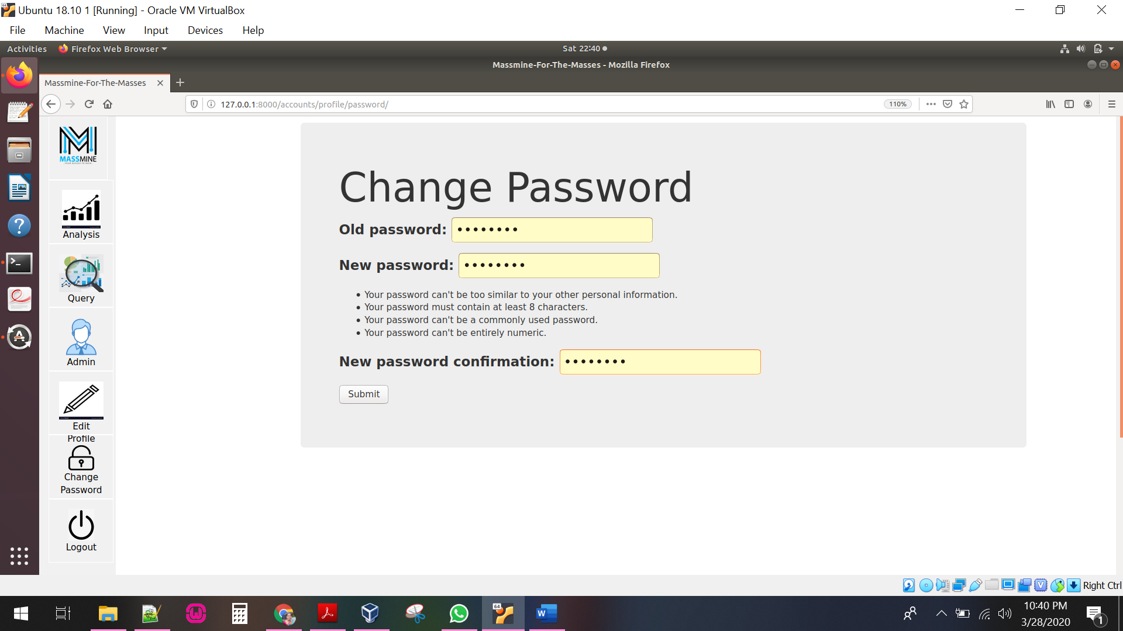

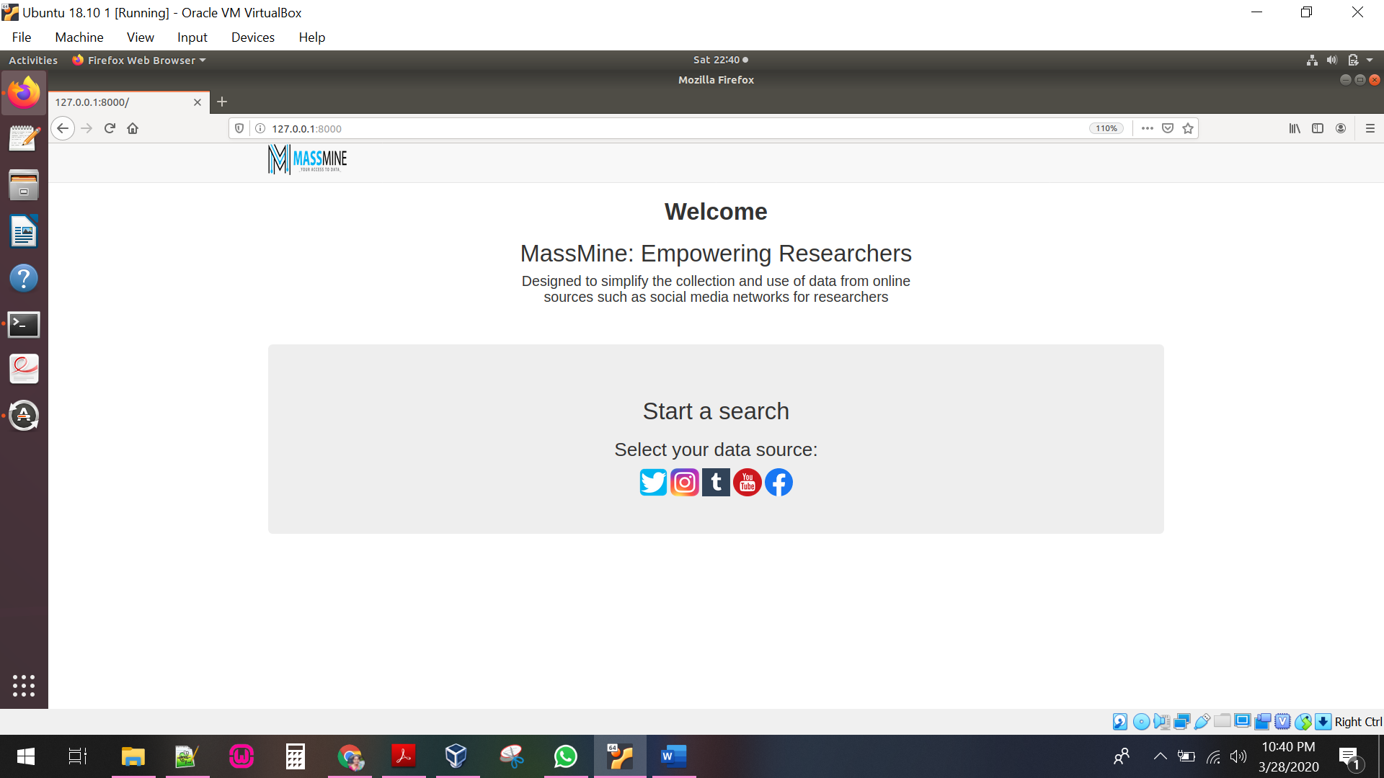

**Deleting A User Scenario:**

Case: Deleting a user using admin

Actor: Admin user named Anusha, currently logged out.

Scenario: Anusha, an admin in the department, is told that AnuVanama is no longer using the account she made. She logs in to the webpage with her

basic user account and clicks on ‘Admin’ icon located in the side navigation bar. She is navigated to a new page where she enters the admin username and password. She clicks on ‘Users’ under the ‘Authentication and Authorization’ tab, then clicks on the ‘AnuVanama’ username. She scrolls to the bottom of the page and clicks on the delete button. She is navigated to a page which prompts for confirmation, and she clicks ‘Yes, I’m sure’. She is then returned to the

Authentication and Authorization page, where a notification at the top of the screen says that the user ‘AnuVanama’ was deleted successfully and AnuVanama is no longer in the list of users.

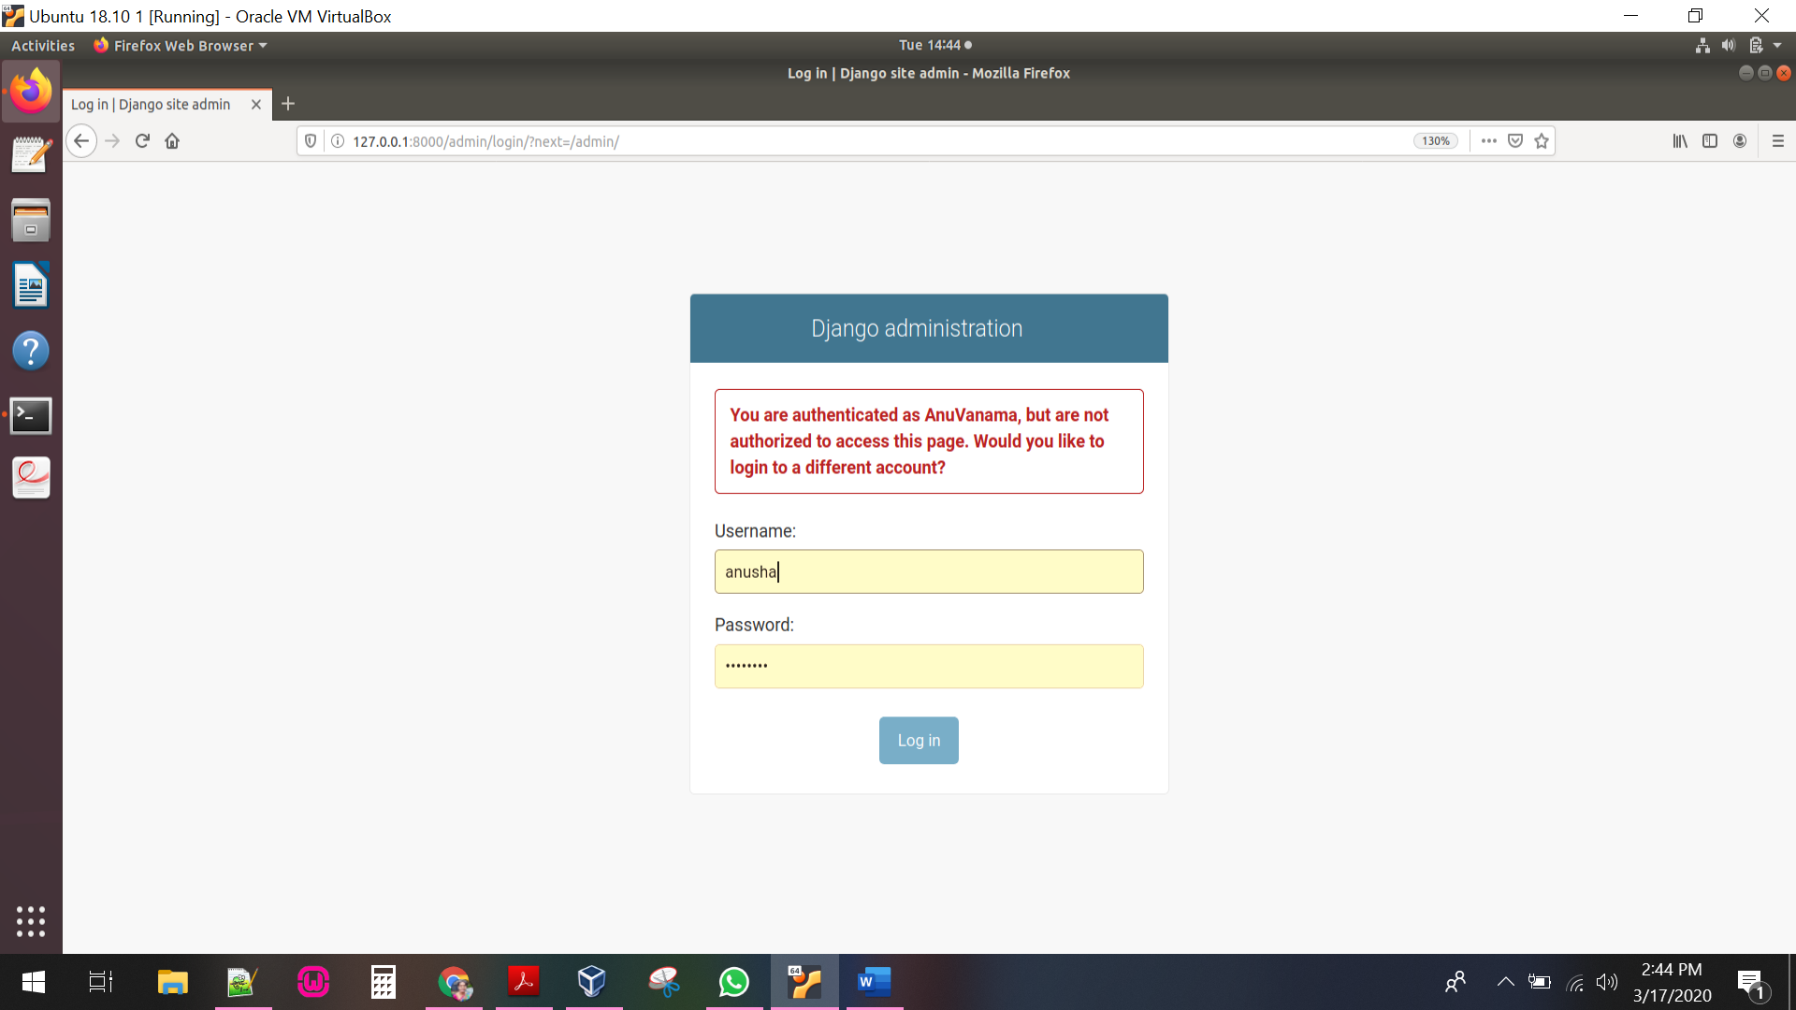

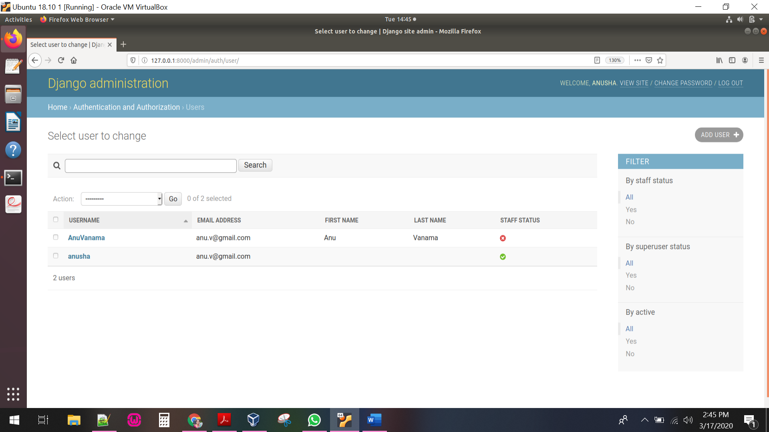

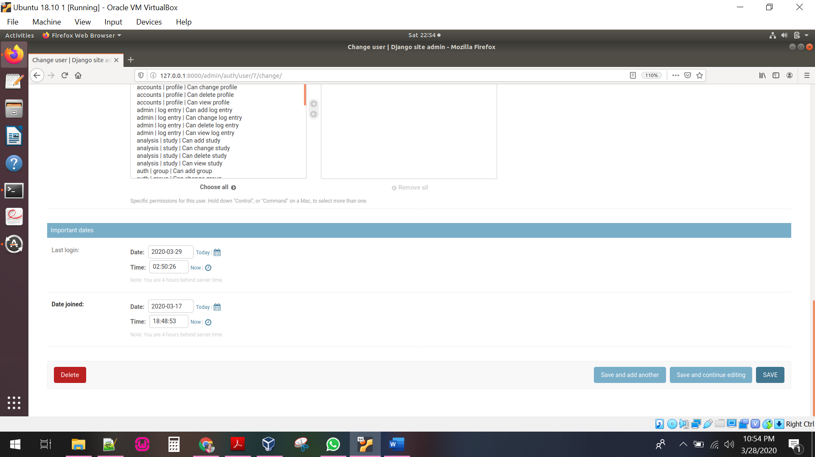

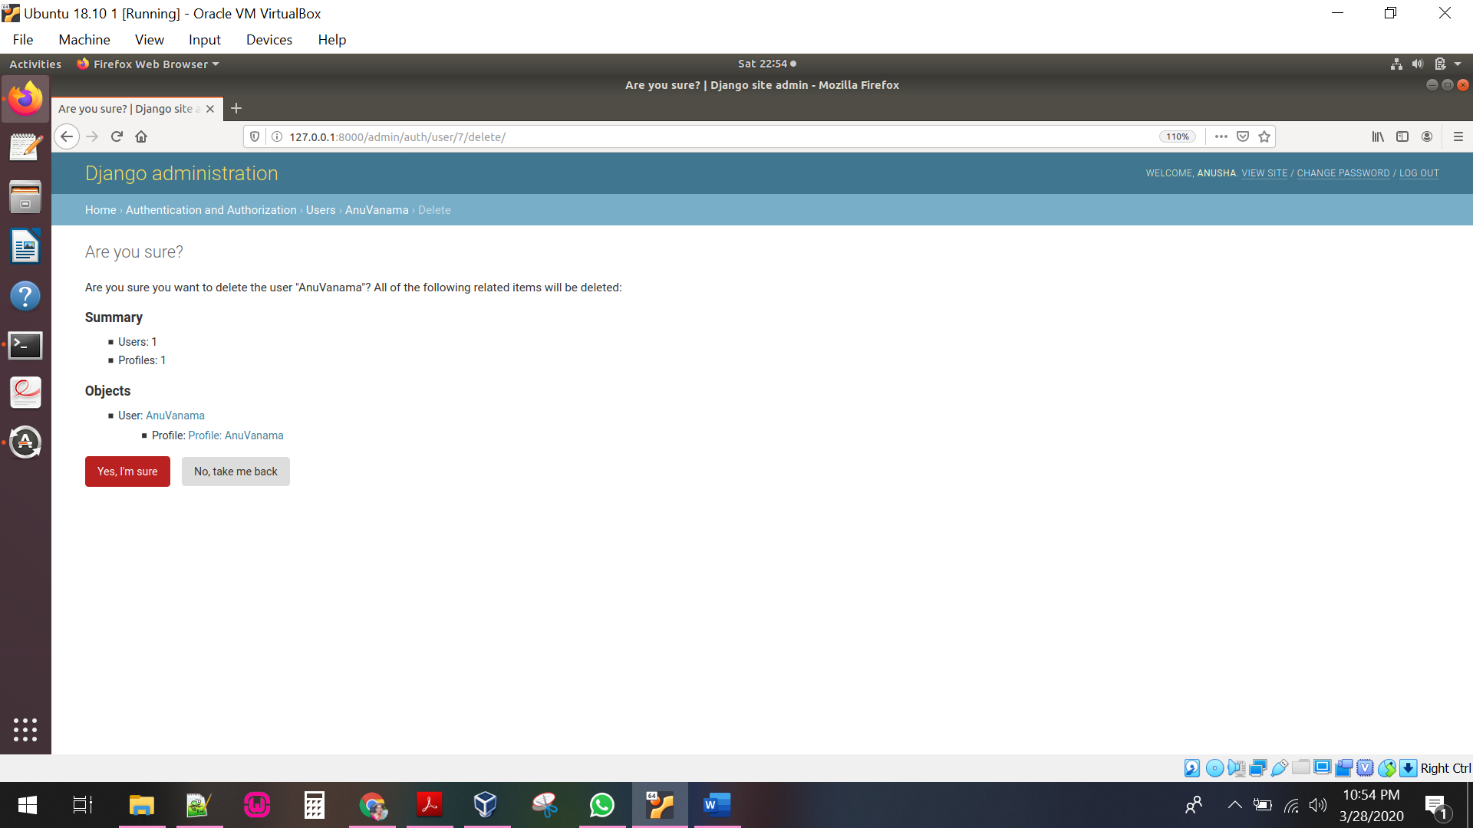

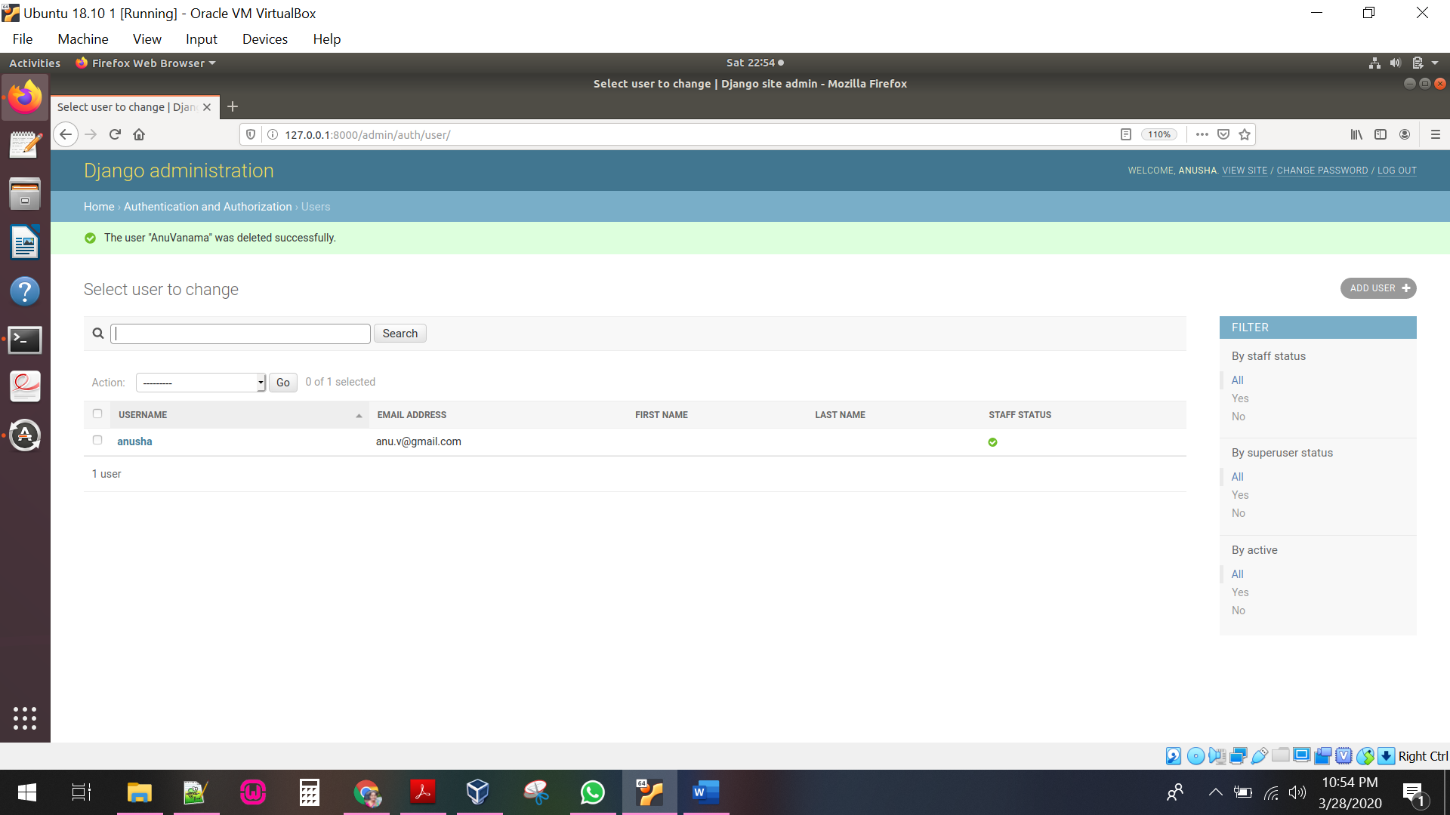

CHAPTER Five  
Conclusion

The goal of this project is achieved by simplifying the process for the average user and enhancing the user experience by offering smooth navigation throughout its design. Redesigned all the webpages that allows a user to create queries for Twitter data in a simple, easily understandable user interface. The analysis page is also modified in such a way that the user can view all the studies in a table and select the studies to create analysis.